**Medical Inventory Management**

College Name : St Joseph’s college for women

College Code : bru4i

TEAM ID : NM2025TMID22079

TEAM MEMBERS : 5

* Team Leader : Aameena Aaysha S

Email:ayshashafeer786@gmail.com

* Team Member : Asmitha A

Email:asmi362006@gmail.com

* Team Member : Shafia S

Email:shafiasshafia@gmail.com

* Team Member : Rejwana A

Email:rejwanareju30@gmail.com

* Team Member : Thasneem Ferdhous S

Email:thasneemferdhouss@gmail.com

**Introduction** :

* 1. **Project Overview**

This project is a comprehensive Salesforce application to streamline and manage various operational aspects of medical inventory. The system aims to efficiently maintain supplier details, manage purchase orders, track product details and transactions, and monitor the expiry dates of products. Maintain detailed records of suppliers, including contact information. Catalog product information, including descriptions, stock levels. Monitor and track product expiry dates to avoid using expired items. Comprehensive reports to track supplier performance, and purchase orders.

* 1. **Purpose**

The purpose of the Medical Inventory Management System is to streamline the tracking and management of medical supplies in healthcare facilities. It aims to reduce wastage, prevent stockouts, and ensure timely availability of essential items. The system improves operational efficiency, enhances patient care, and supports better decision-making through real-time data and reporting.

**DEVELOPMENT PHASE**

**Creating Developer Account:**

By using this URL - https://www.salesforce.com/form/developer-signup/?d=pb



* **Created Object : Product**

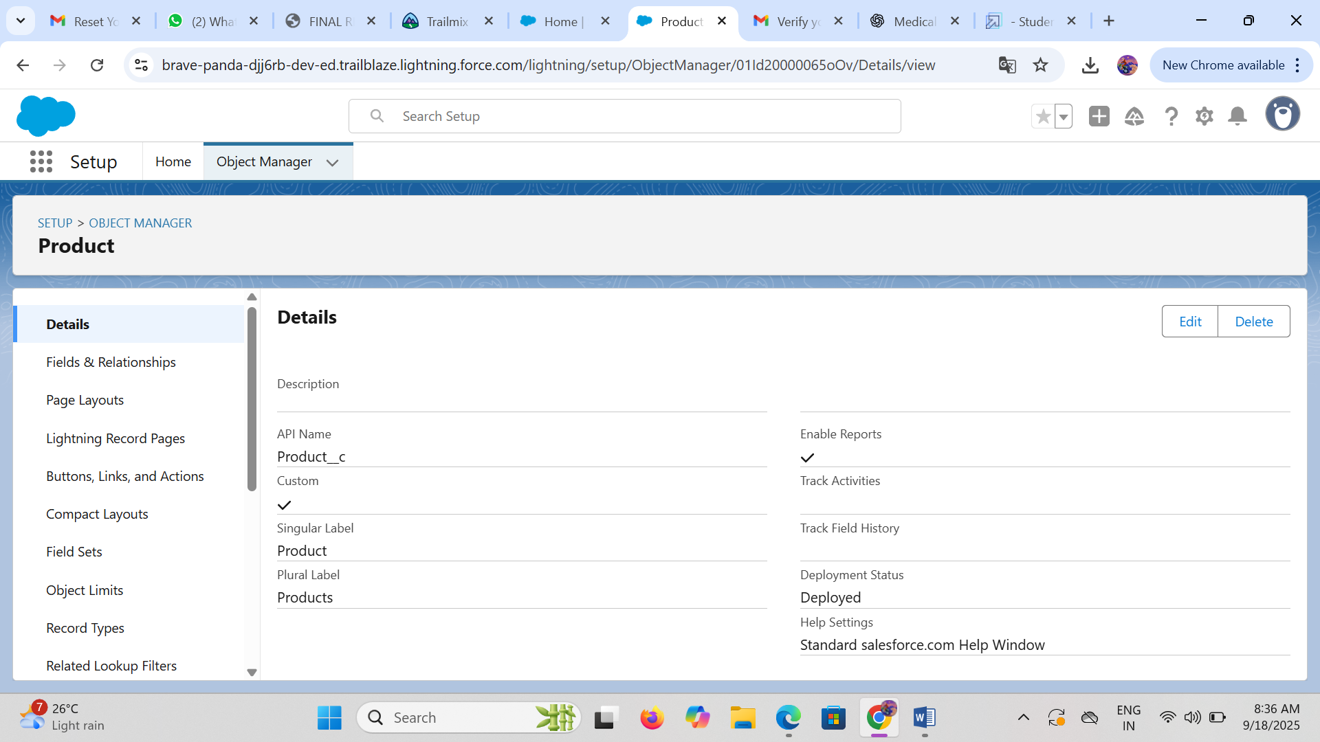

* **Create Custom Tabs :**

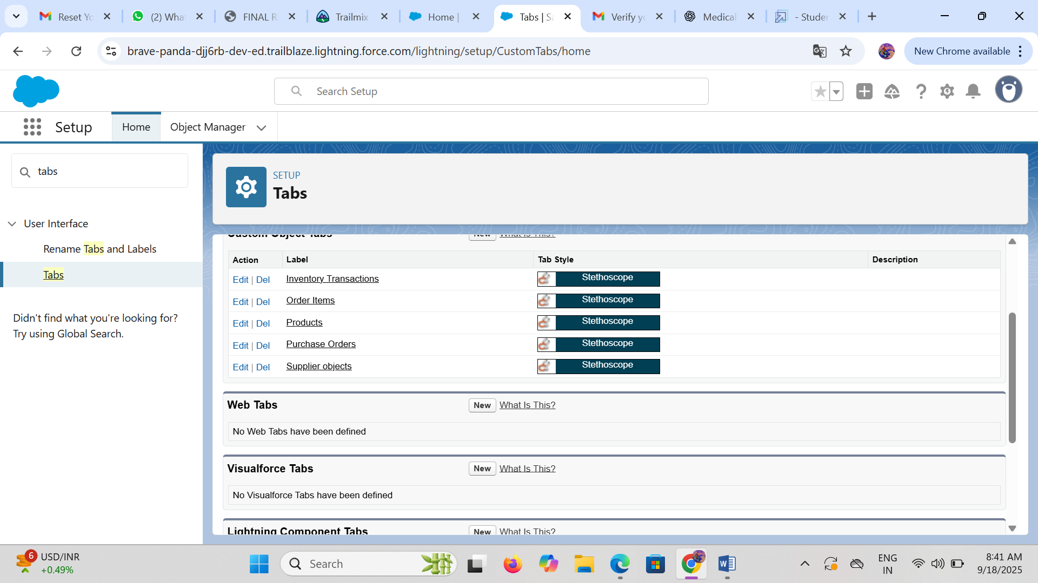

* **Developing Lightening App with relevant tabs:**

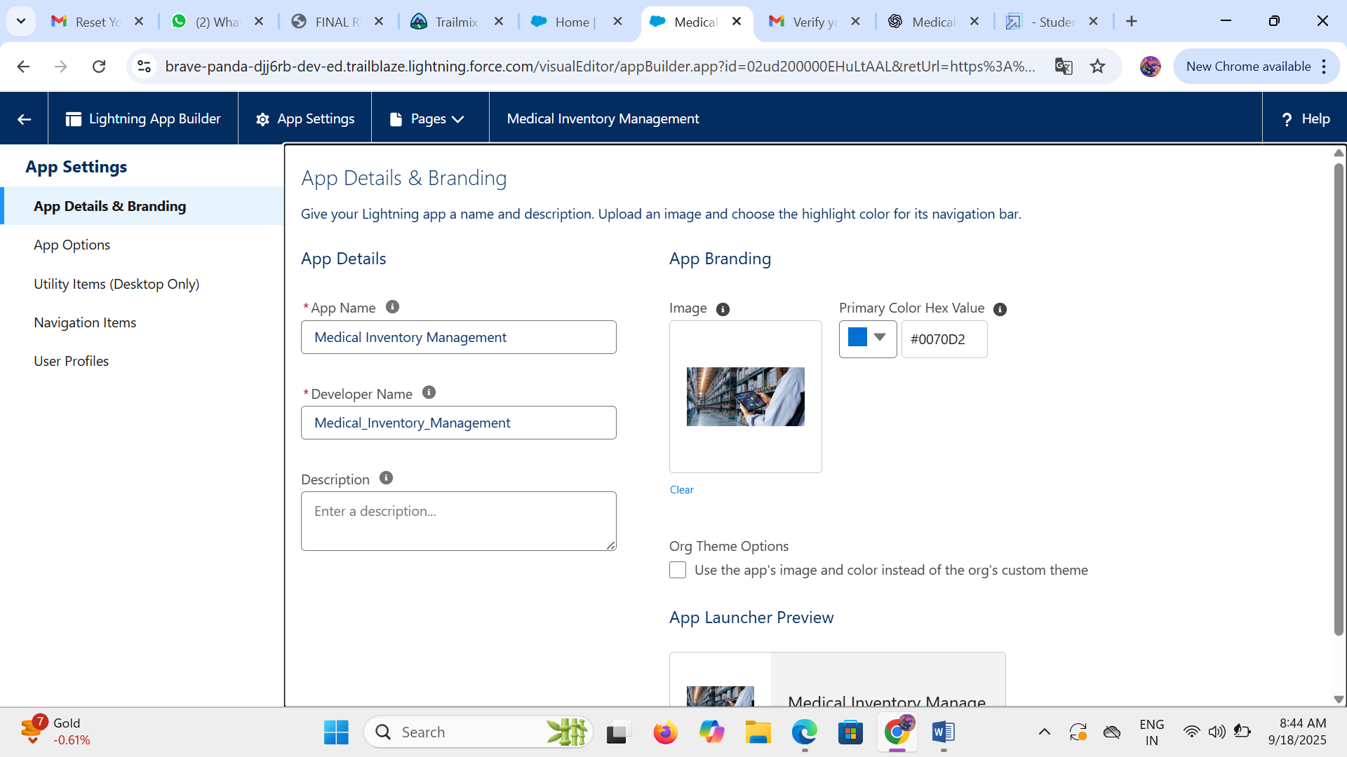

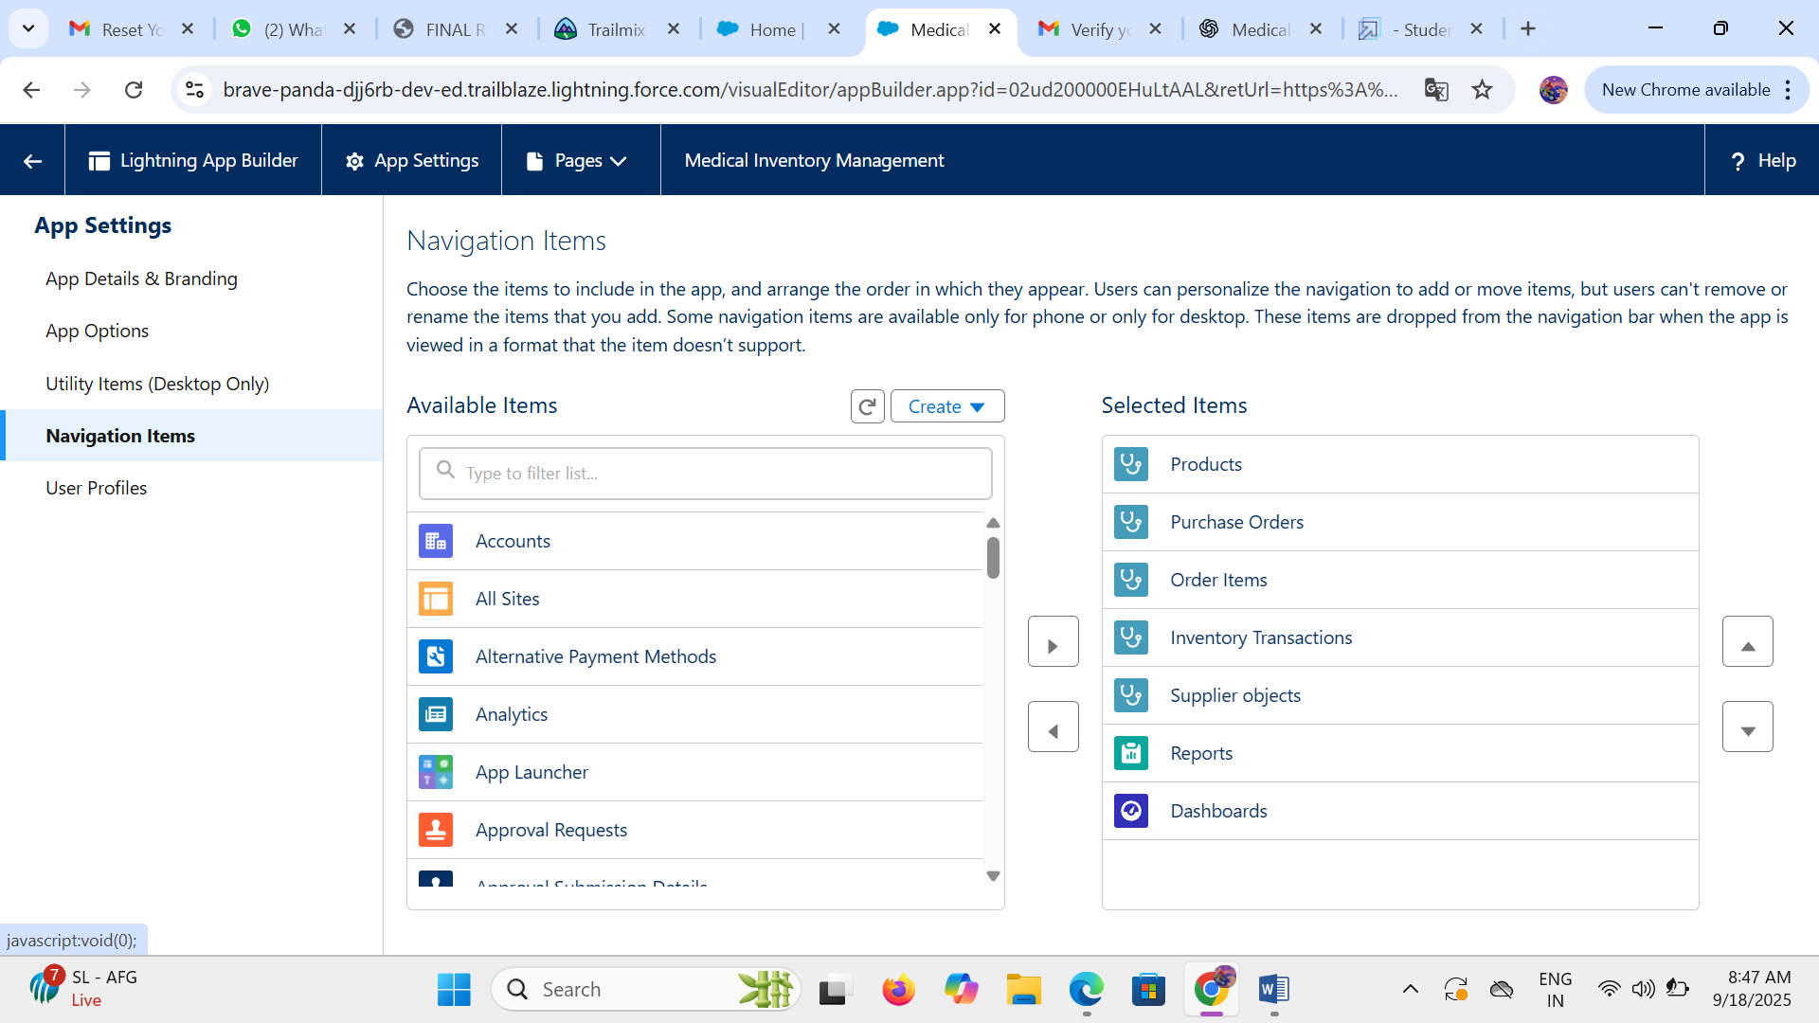

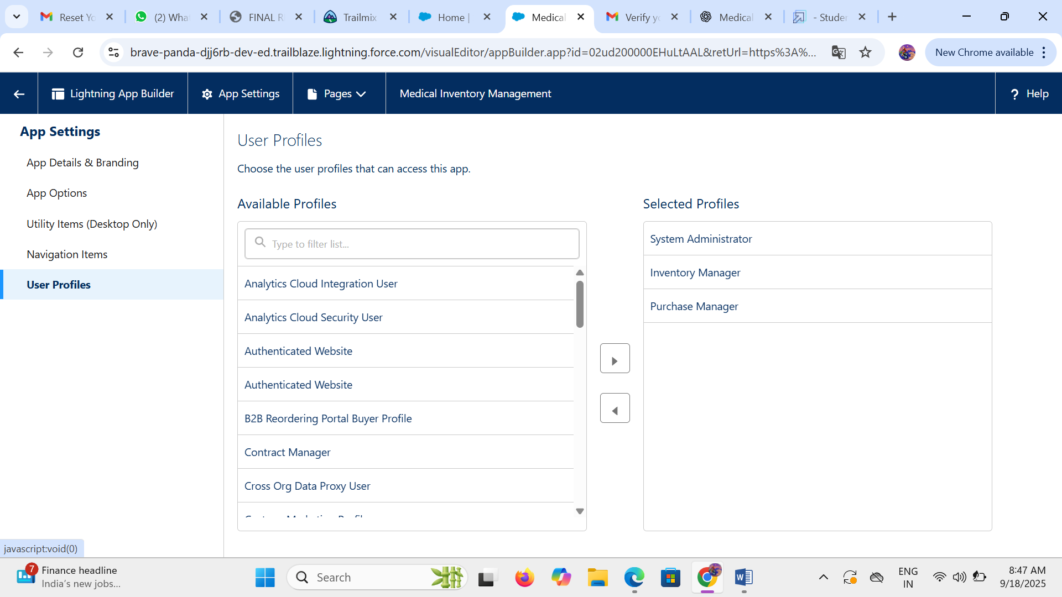

* **Configured Field and Relationships**

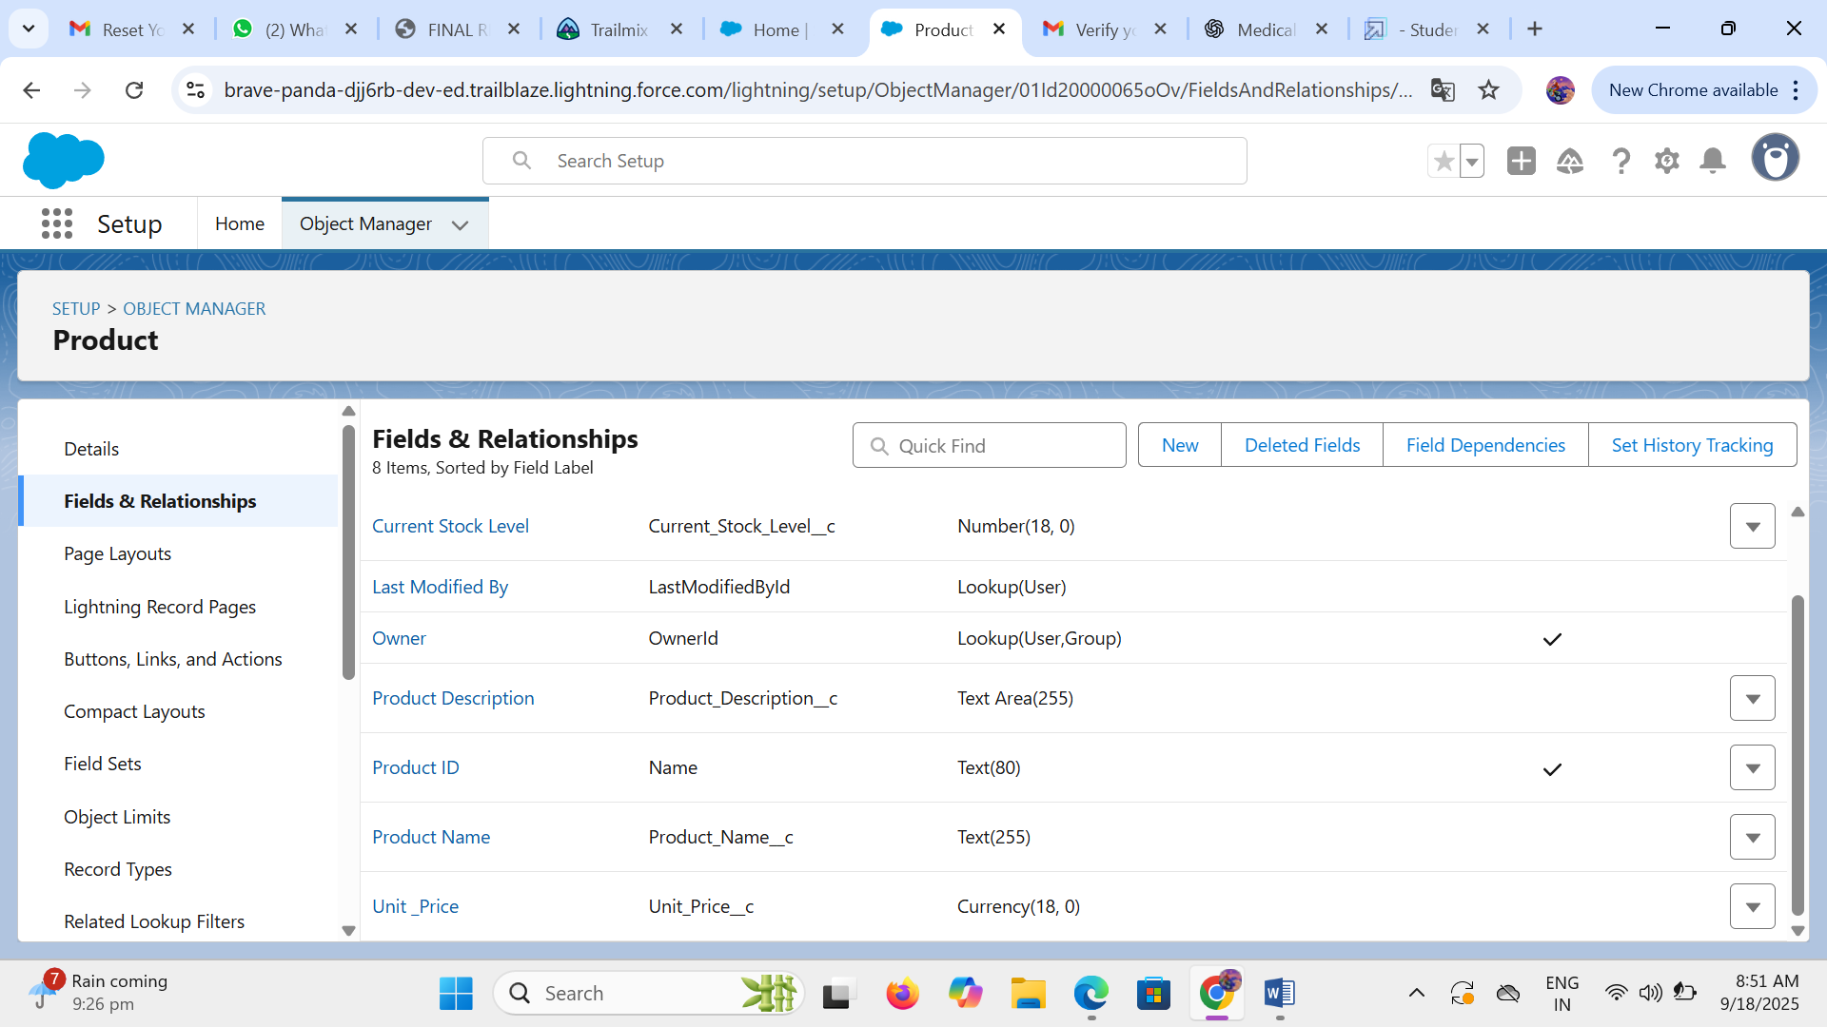

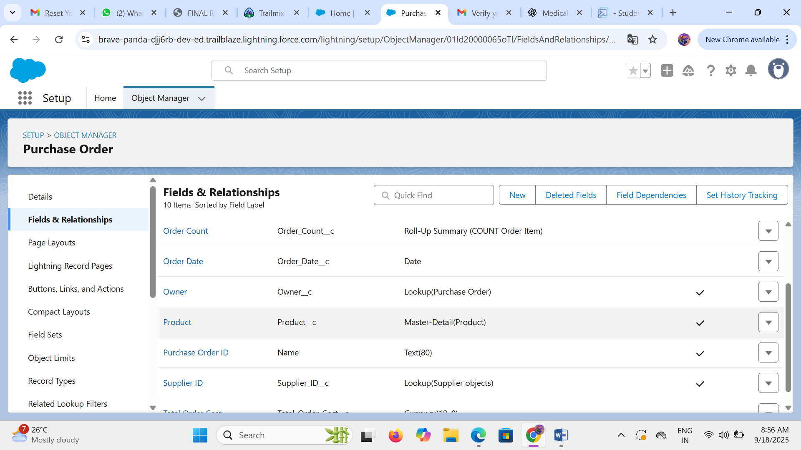

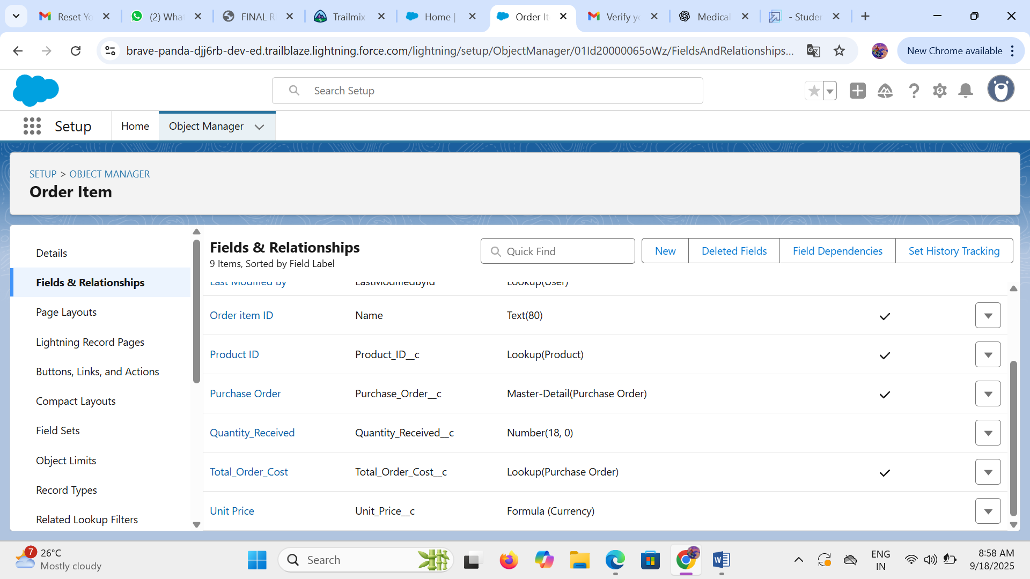

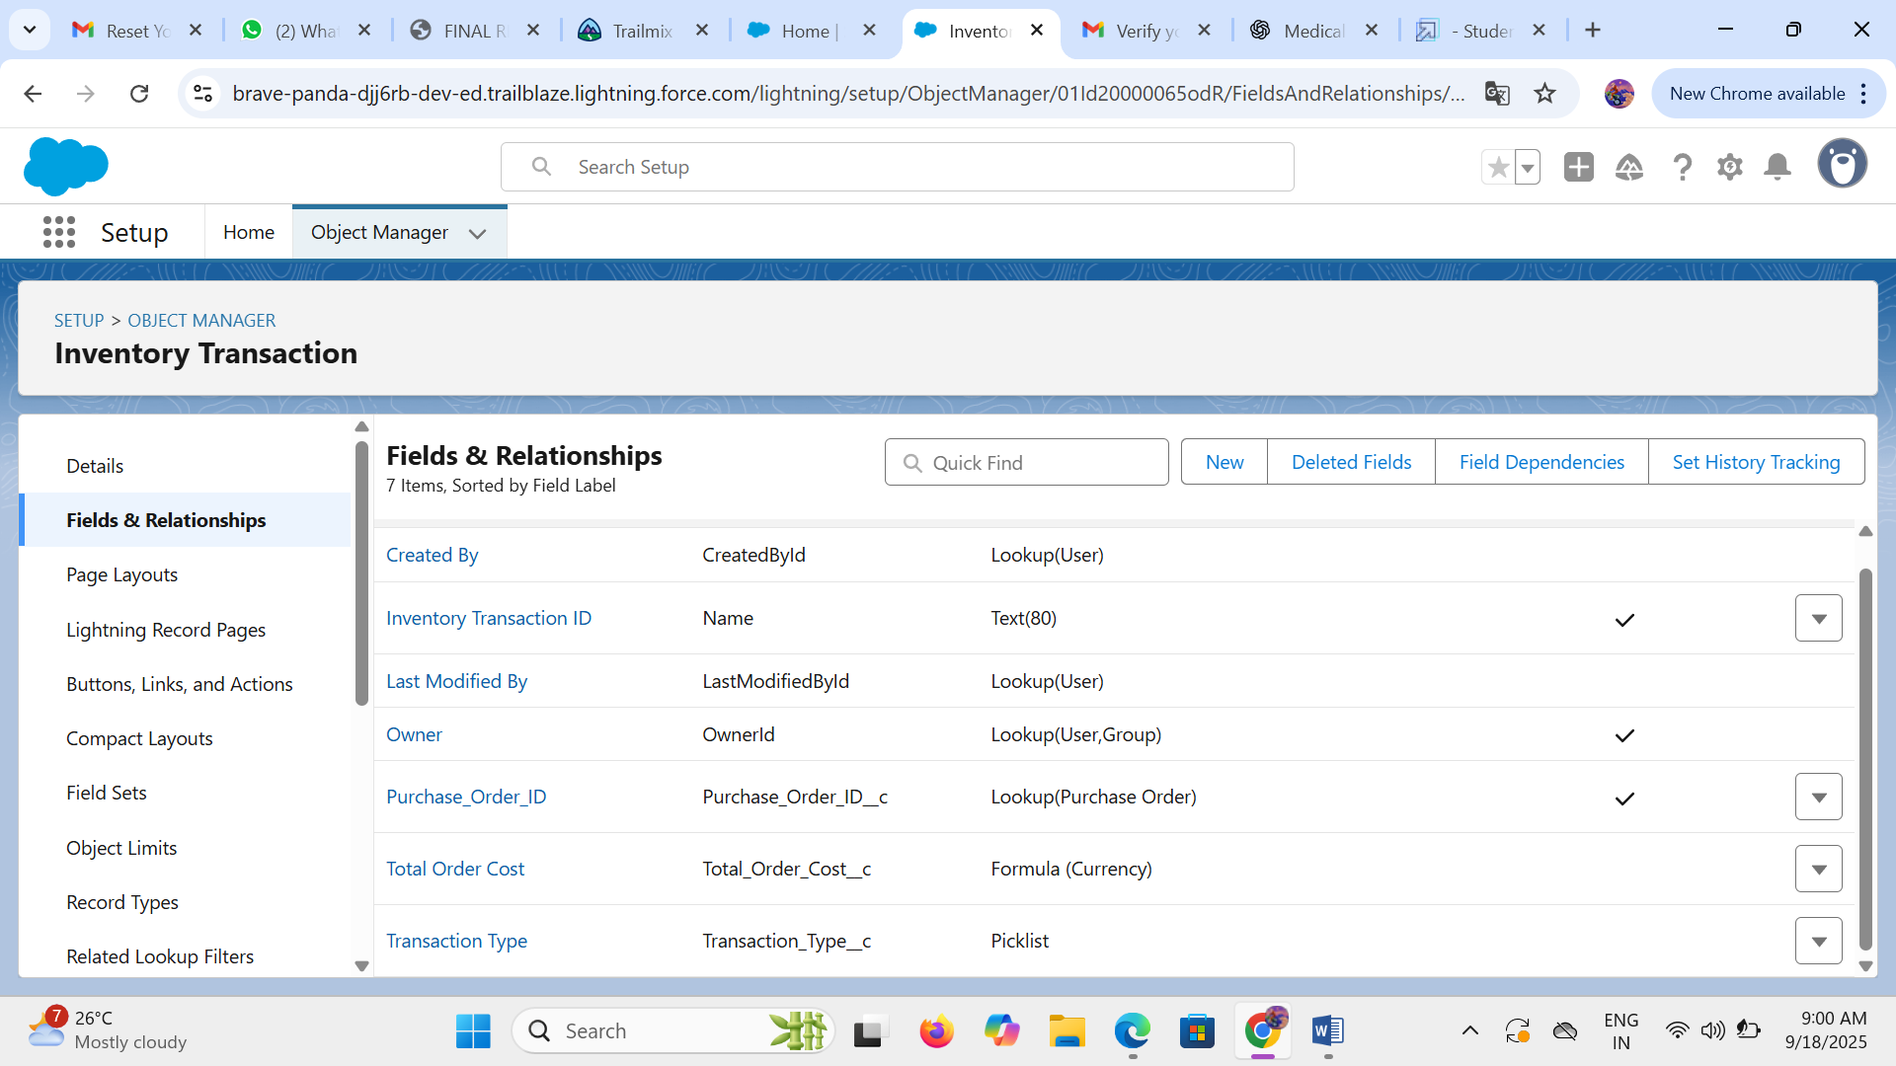

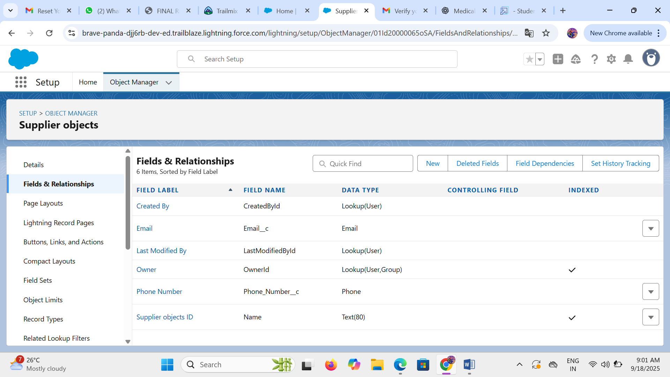

* **Page Layouts :**

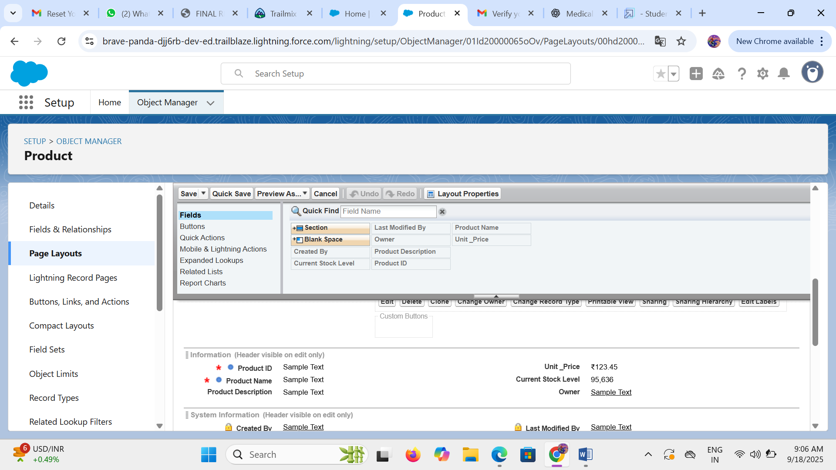

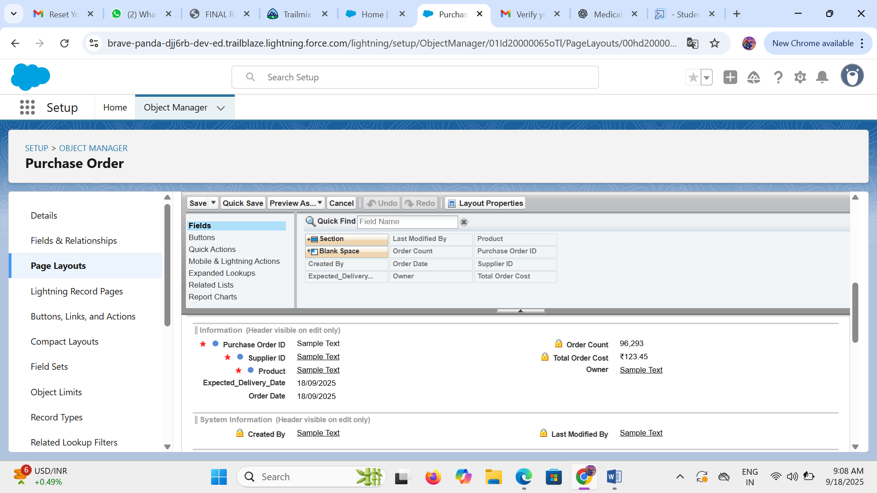

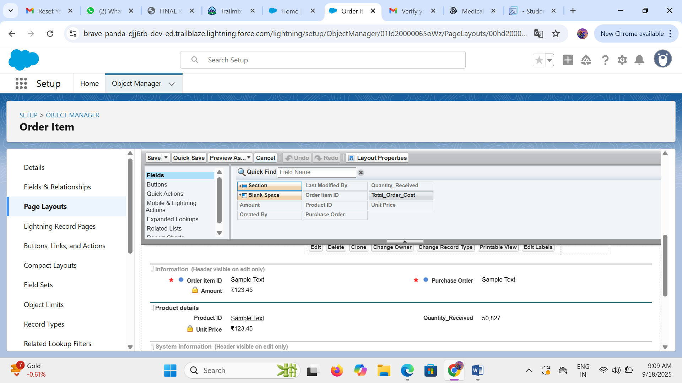

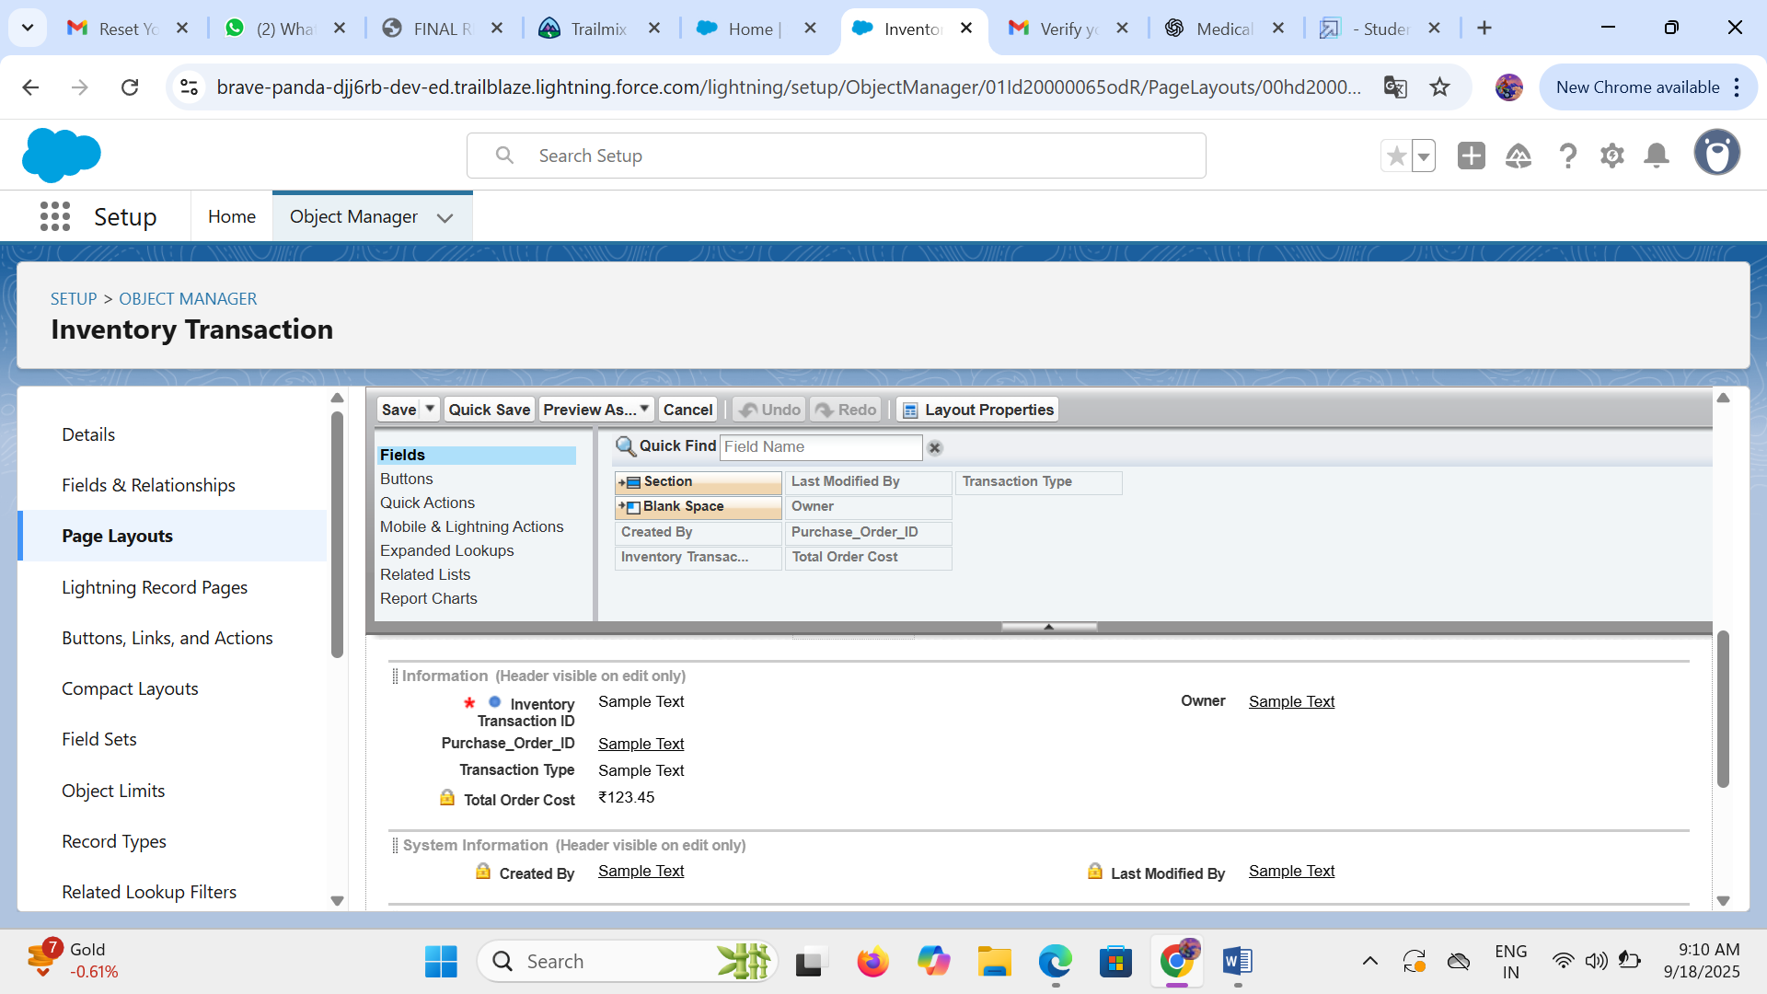

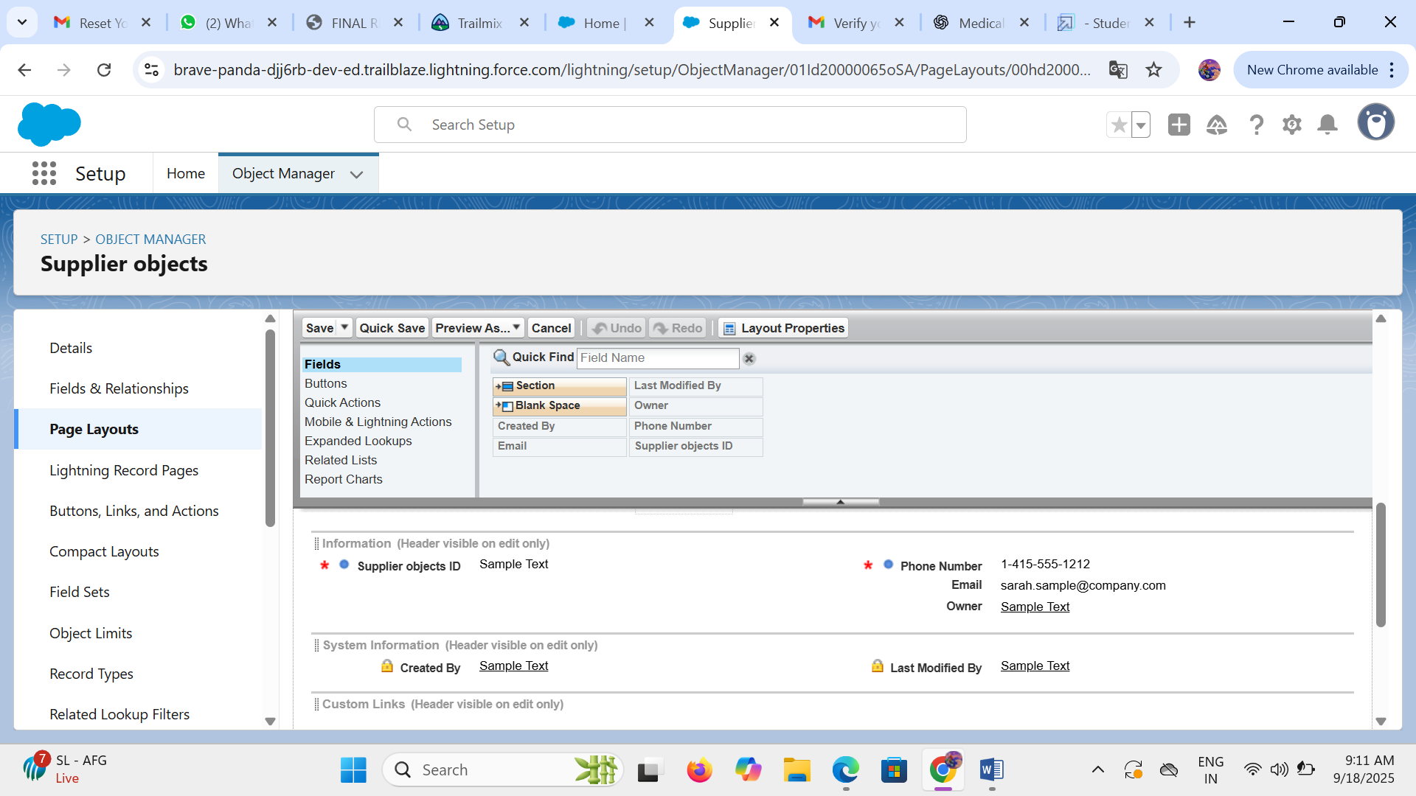

* **Compact Layout :**

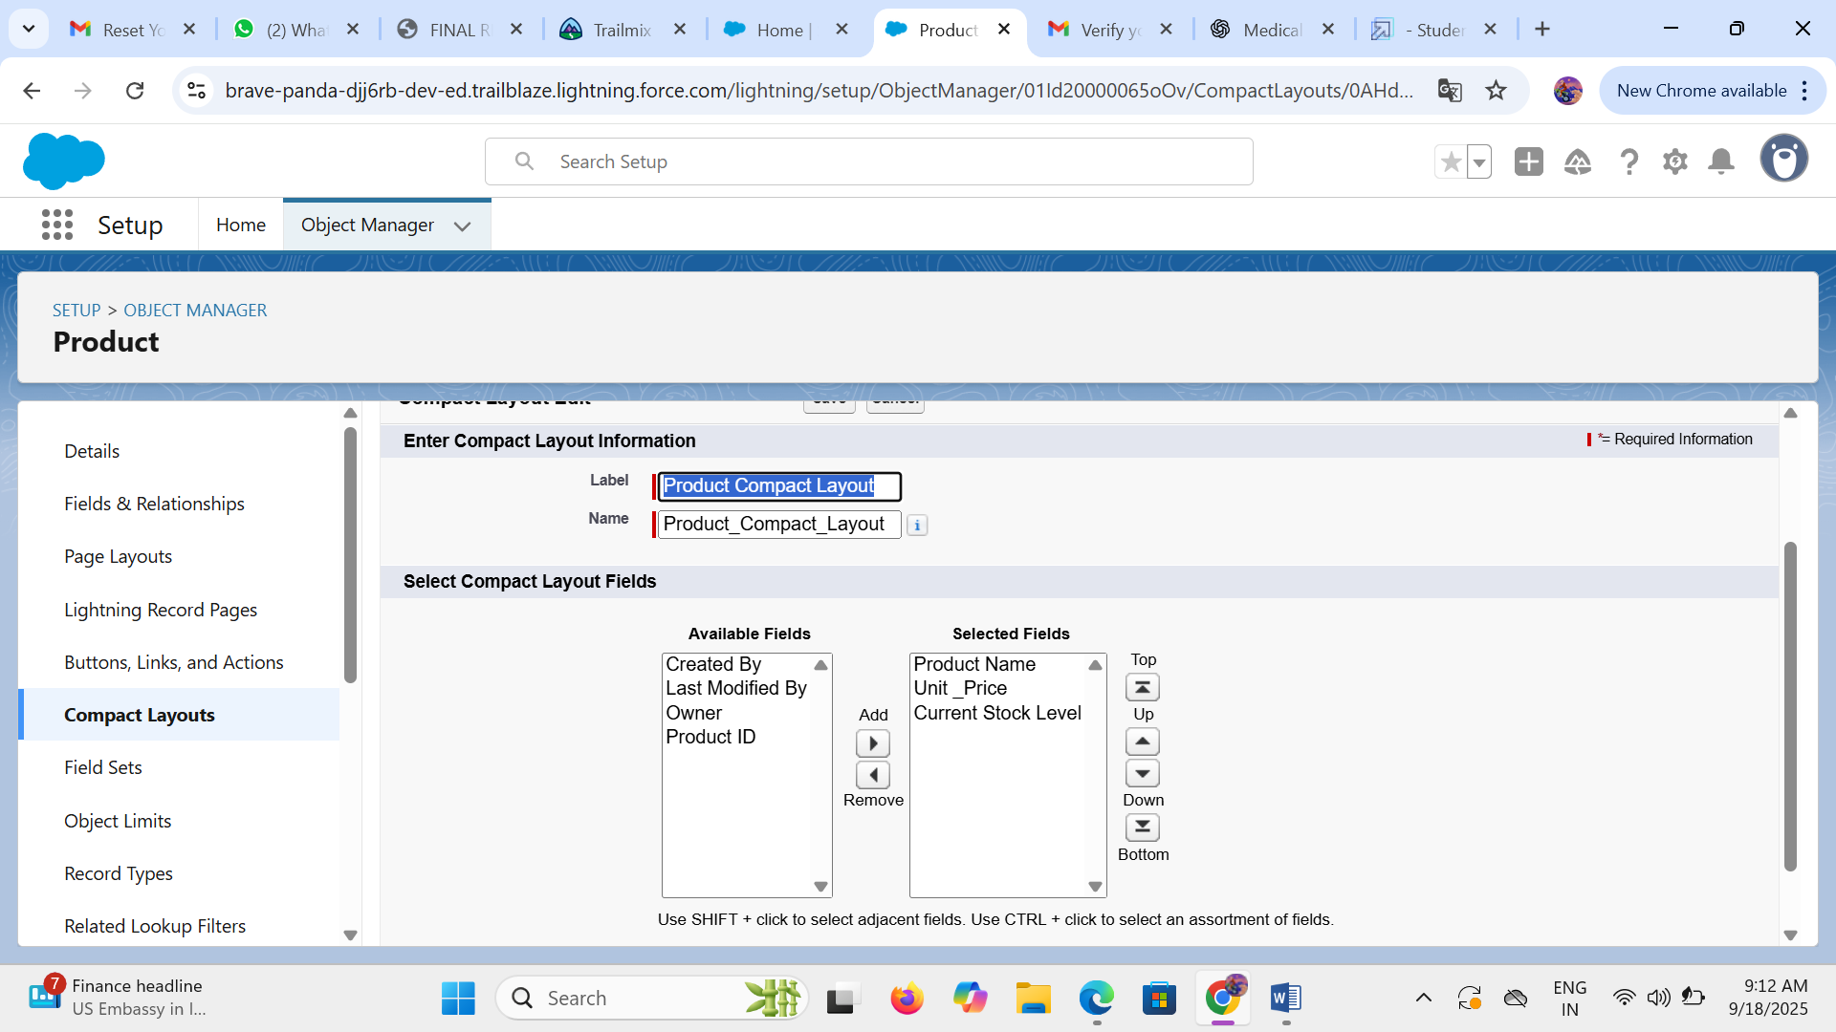

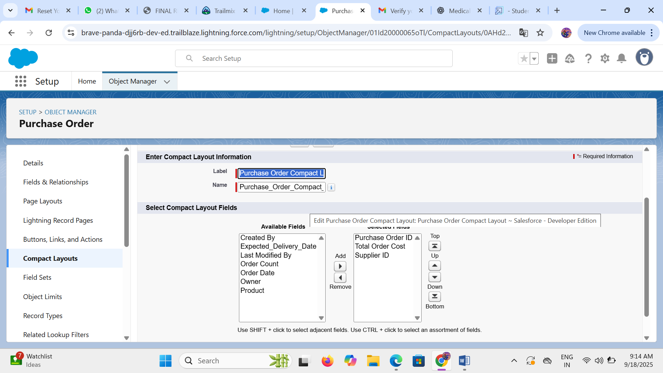

* **Validation Rules :**

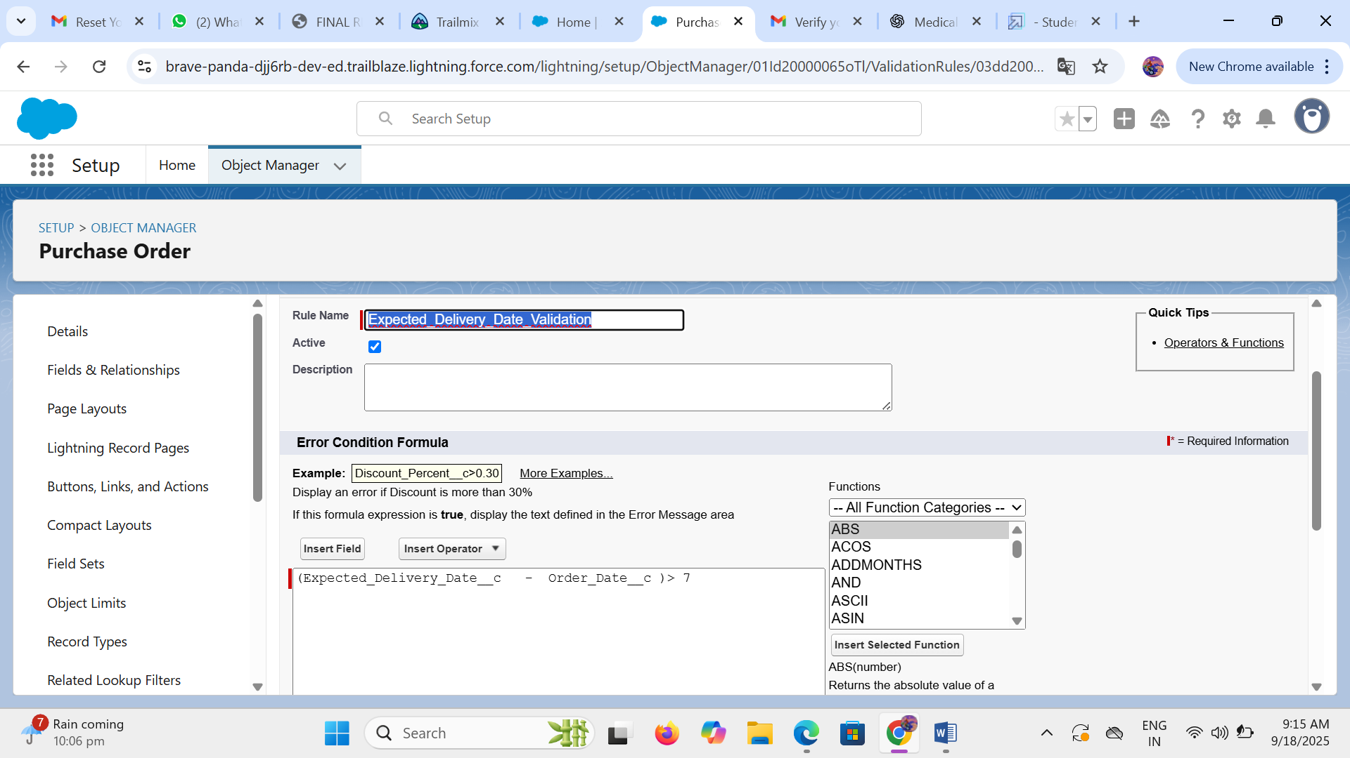

* **Profiles** :

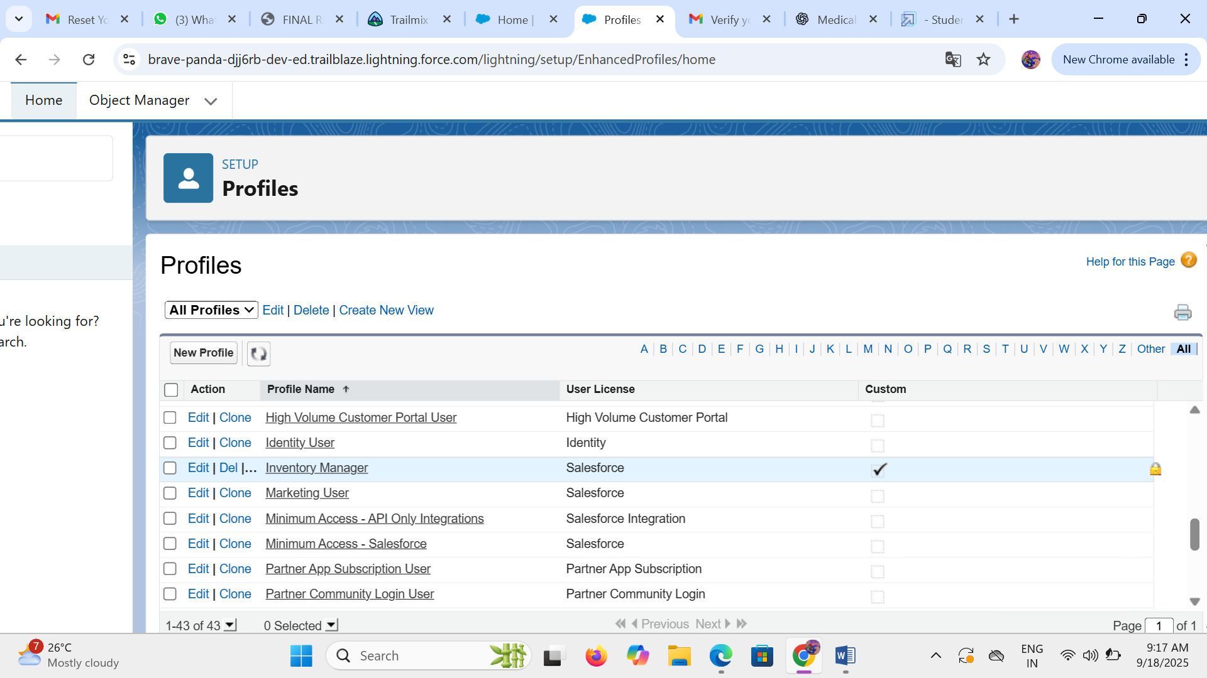

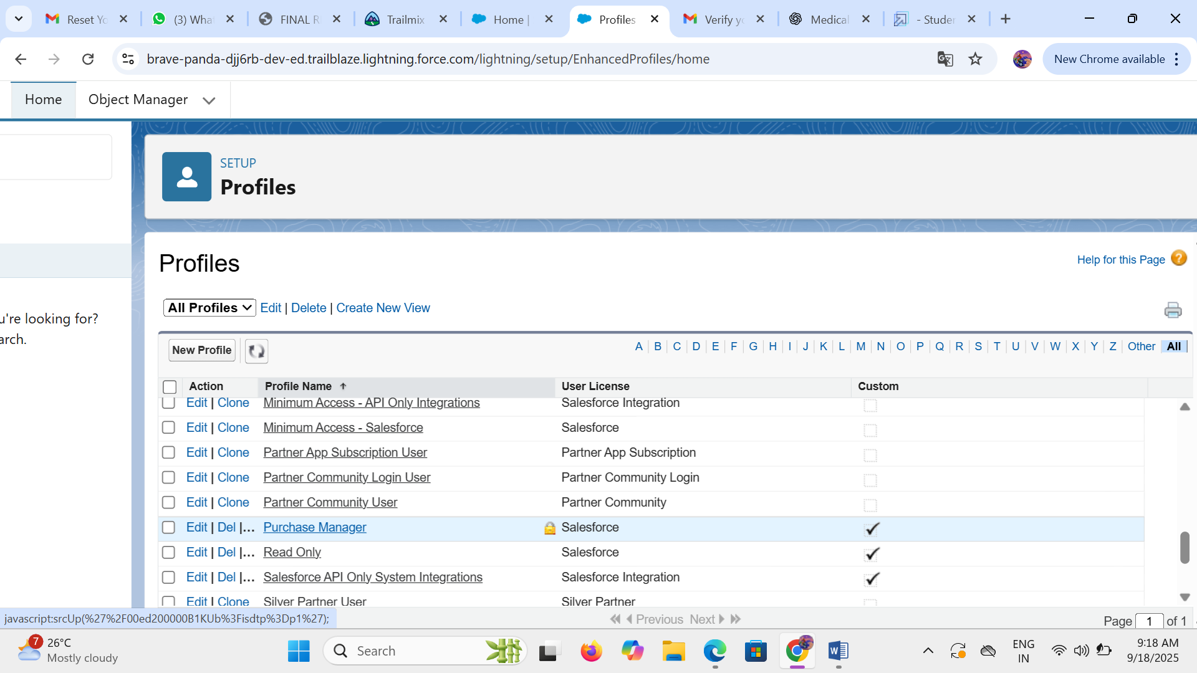

* **Roles** :

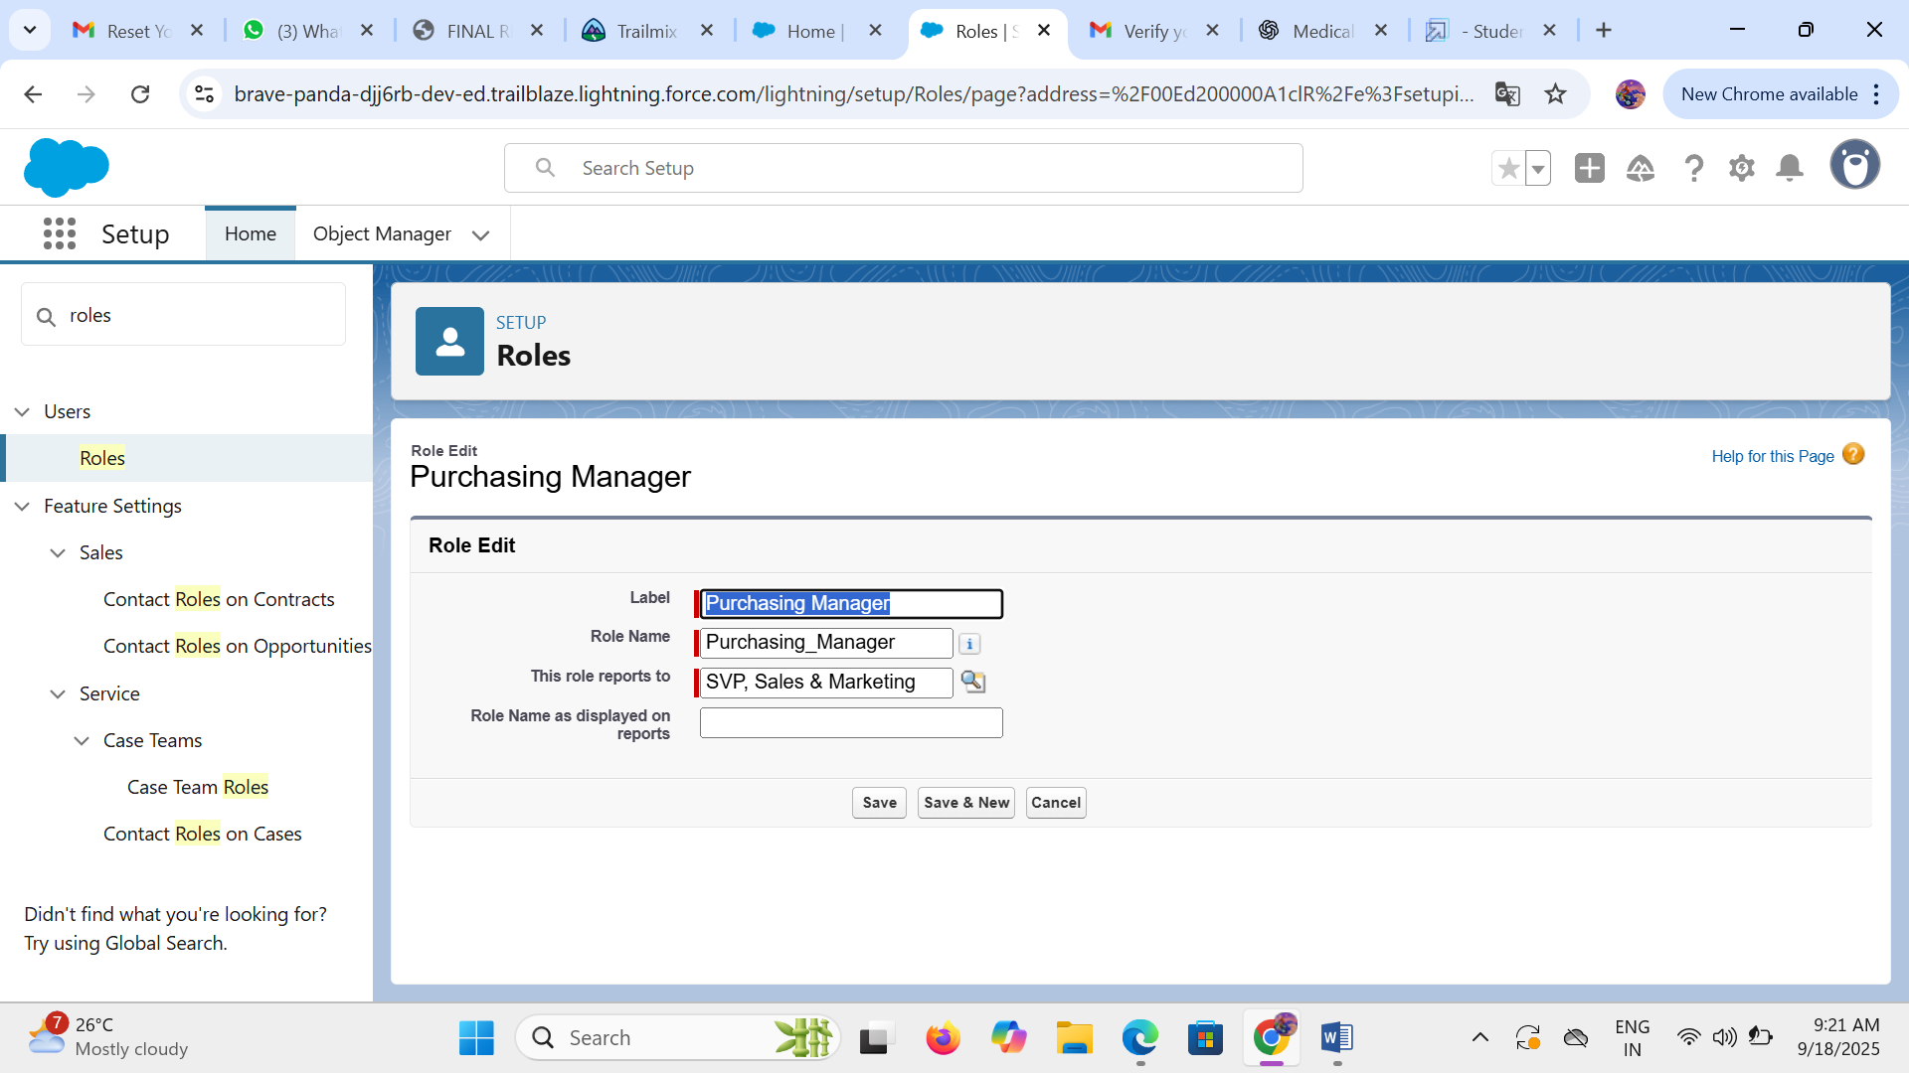

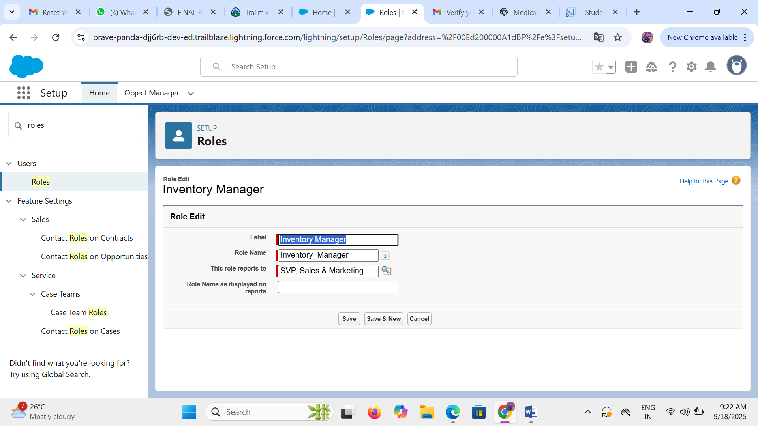

* **User** :

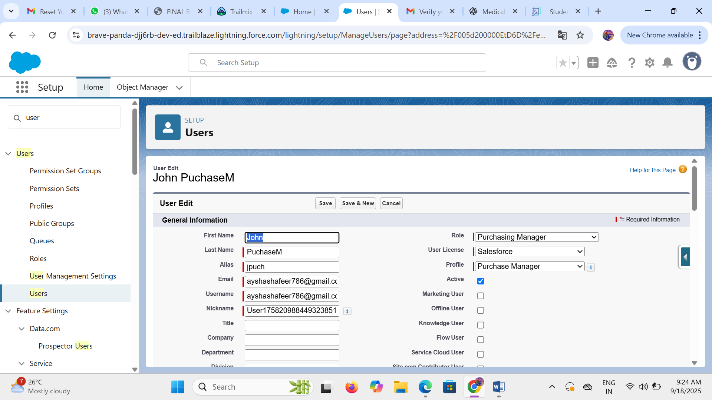

* **Create a permission set :**

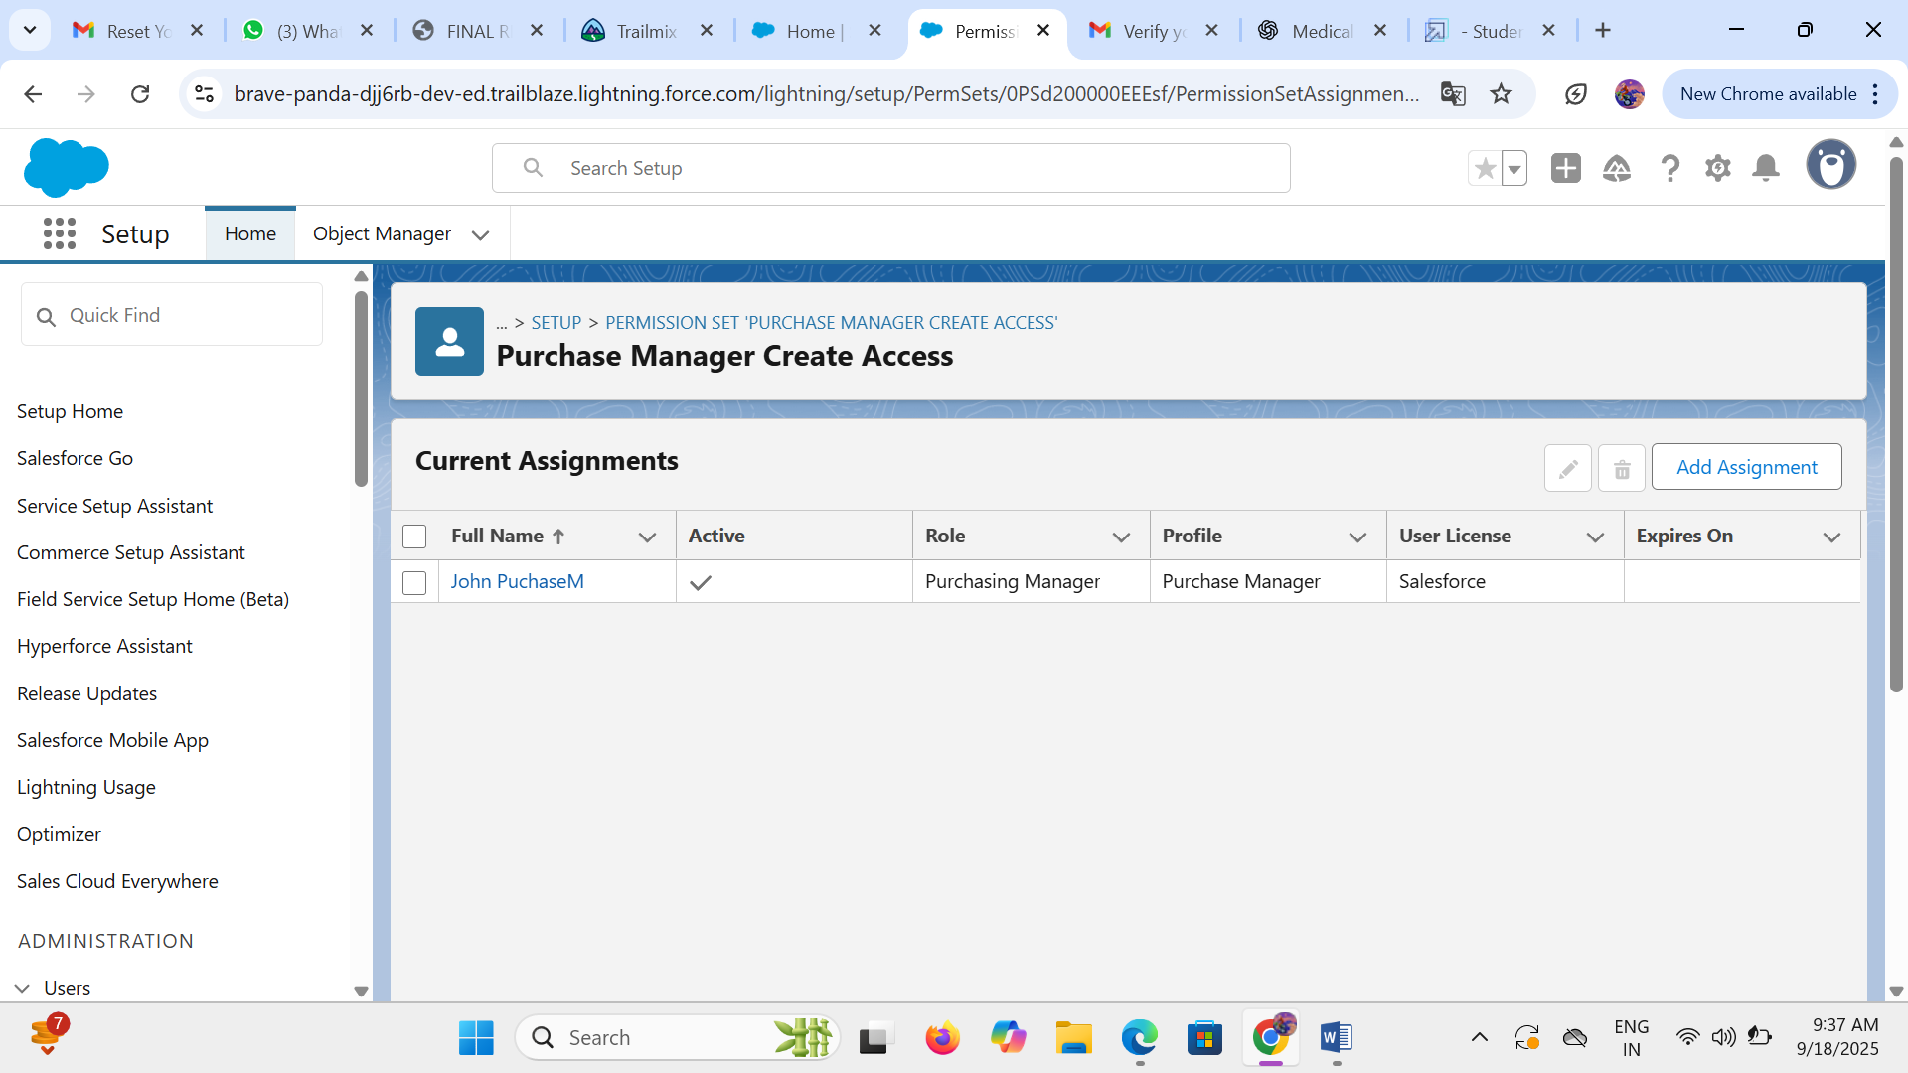

* **Flows** :

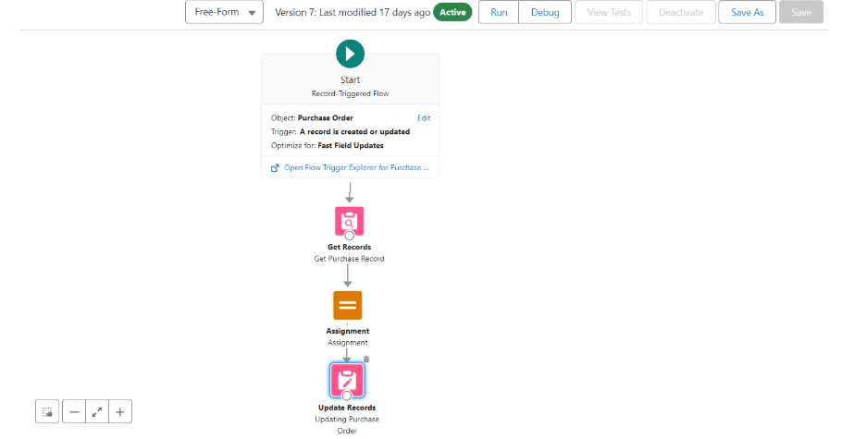

\

* **Triggers**:

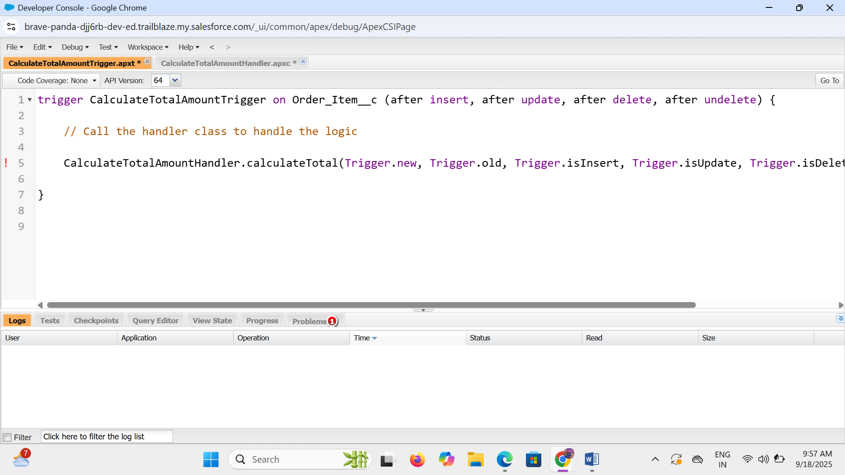

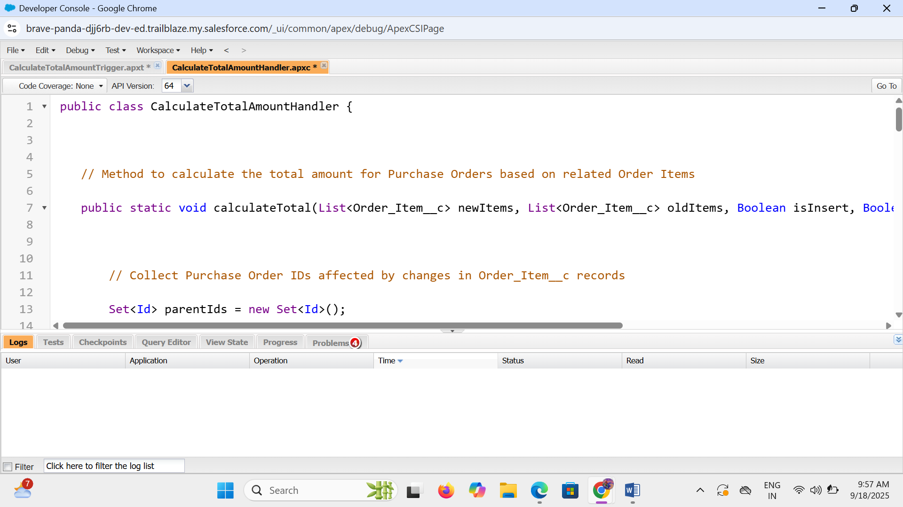

* **Creating an complete purchase reports :**

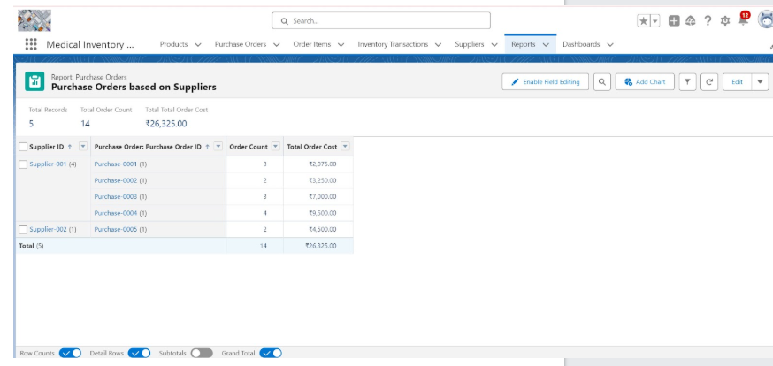

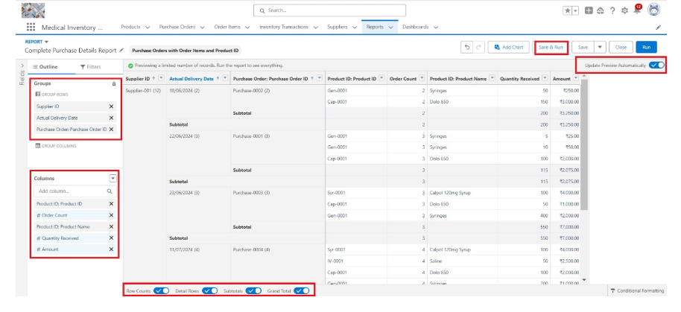

* **Creating and Viewing a dashboard :**

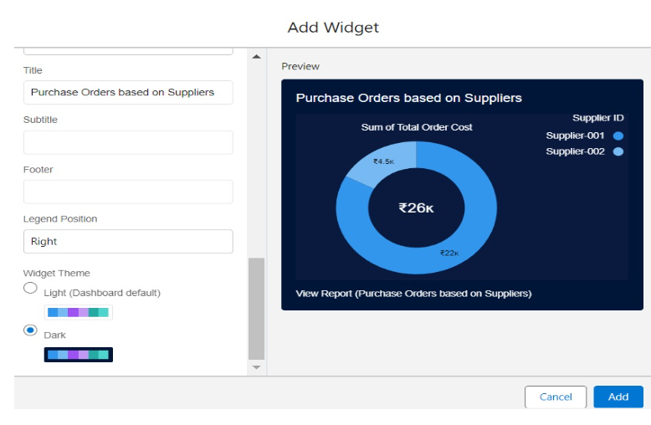

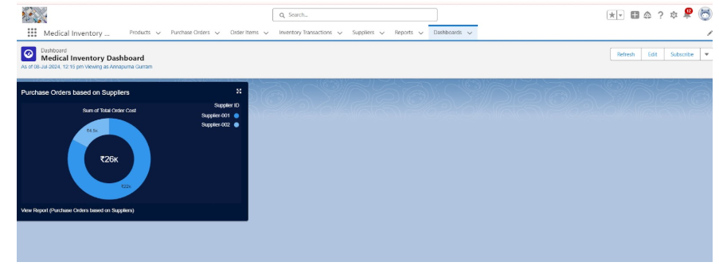

* **Conclusion :**

Effective medical inventory management is crucial for ensuring the continuous availability of essential medical supplies, minimizing waste, and enhancing patient care. By implementing robust inventory control systems, healthcare facilities can reduce costs, prevent stockouts and overstocking, and improve operational efficiency. Modern technologies such as barcode scanning, RFID, and inventory management software play a significant role in streamlining the process and providing real-time visibility into stock levels. Ultimately, a well-managed medical inventory system not only supports clinical operations but also contributes to better healthcare outcomes and resource optimization.